Proposed solution in third party service provider and insurer and masters.

1) Changes on Own Damage

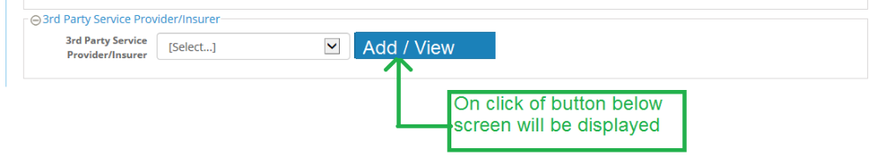
2) Popup screen after click on button.

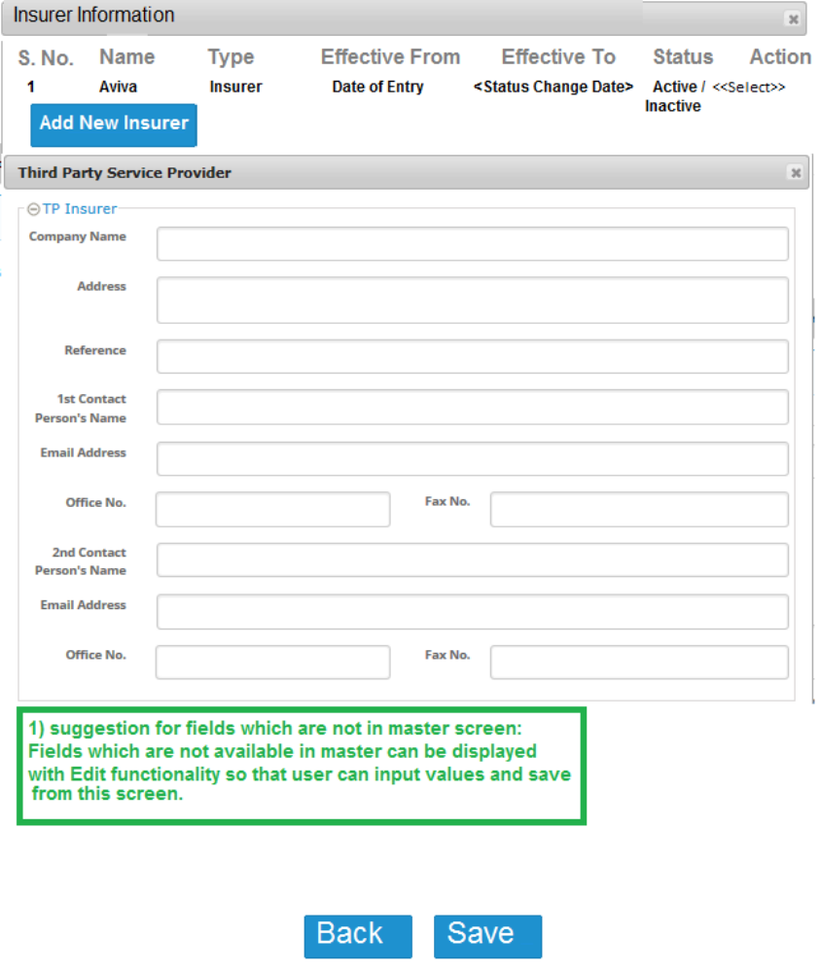

Below fields are not exist in master screen.

1) Reference
2) 1st person contact person name
3) 2nd person contact person name
4) 2nd person contact person email address
5) 2nd person contact person office no.
6) 2nd person contact person fax no.

Doubt:
1) Can we make above listed field editable in add insurer popup screen, so that user can input value from this screen for missing field?

3 Changes in Insurer master screen

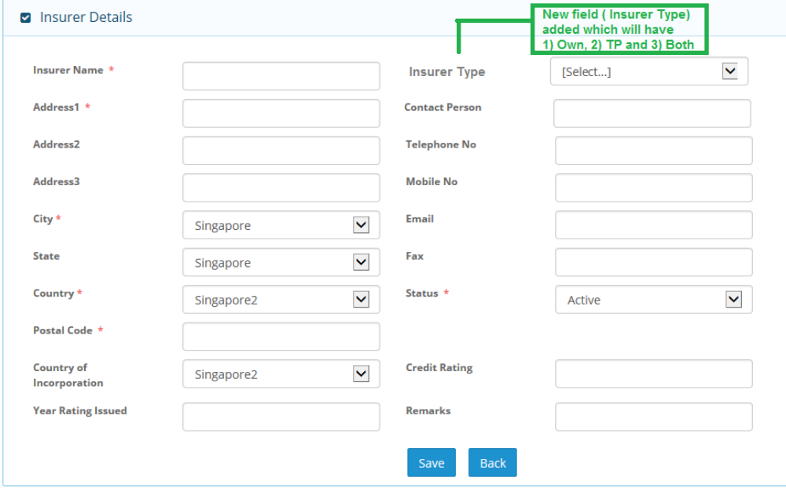
1) Insurer type drop down list can be added in insurer master.
2) Three option can be added in drop down list as below:
a) Own
b) TP
c) Both
3) “Own” and “Both” type of Insurer can be displayed in “Our Insurer“ drop down list
4) “TP” and “Both” type of Insurer can be displayed in popup screen of “Add new service provider / insurer“ of “TP Insurer”.

